FEDERAL STATE AUTONOMOUS EDUCATIONAL INSTITUTION

OF HIGHER EDUCATION

ITMO UNIVERSITY

Report

on the practical task No. 2

“Algorithms for unconstrained nonlinear optimization. Direct methods”

Performed by

*Vdovkina Sophia*

*Syrchenko Arina*

*Academic group: J4133c*

Accepted by

Dr Petr Chunaev

St. Petersburg

2022

**Goal**

The use of direct methods (one-dimensional methods of exhaustive search, dichotomy, golden section search; multidimensional methods of exhaustive search, Gauss, Nelder-Mead) in the tasks of unconstrained nonlinear optimization.

**Formulation of the problem**

1. Use the one-dimensional methods of exhaustive search, dichotomy and golden section search to find an approximate (with precision 𝜀 = 0.001) solution 𝑥: 𝑓(𝑥) → 𝑚𝑖𝑛 for the set of functions and domains. Calculate the number of f-calculations and the number of iterations performed in each method and analyze the results. Explain differences (if any) in the results obtained.
2. Approximate the data by linear and rational functions by means of least squares through the numerical minimization of the given function. To solve the minimization problem, use the methods of exhaustive, Gauss and Nelder-Mead search. If necessary, set the initial approximations and other parameters of the methods. Visualize the data and the approximants obtained in a plot separately for each type of approximant so that one can compare the results for the numerical methods used. Analyze the results obtained (in terms of number of iterations, precision, number of function evaluations, etc.).

**Brief theoretical part**

**Results**

1. We used the one-dimensional methods of exhaustive search, dichotomy and golden section search to find an approximate (with precision Ɛ = 0.001) solution $x$: $f\left(x\right)→ min$ for the following functions and domains:1. 

2. 

3. 

The results are shown in the pictures 1 – 3.

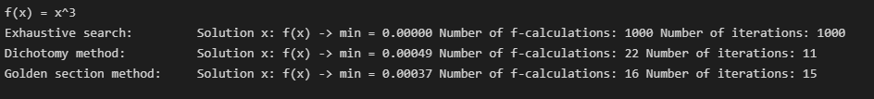

Picture 1 – results for the first function

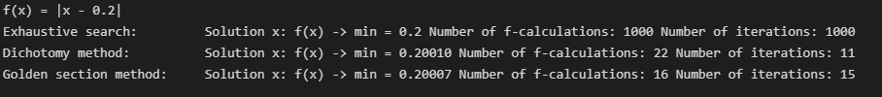

Picture 2 – results for the second function

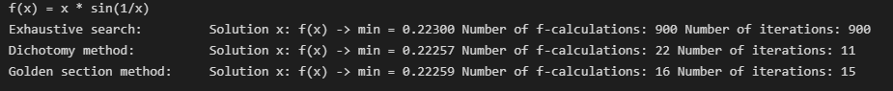

Picture 3 – results for the third function

As it shown in the pictures above all methods found almost the same solution with the given accuracy. The exhaustive search method required maximum number of function calculations and maximum number of iterations. It can be explained as in exhaustive search we should iterate through all possible values.

The golden section method required fewer function calculations as at each iteration (except for the first one) the method requires only one function calculation, in contrast to the

1. Noisy data was generated and approximated by linear and rational functions by means of least squares through the numerical minimization of the given function. To solve the

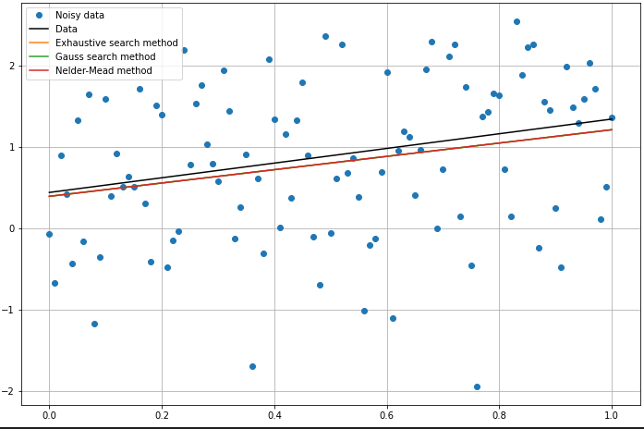

Picture 4 – linear optimization

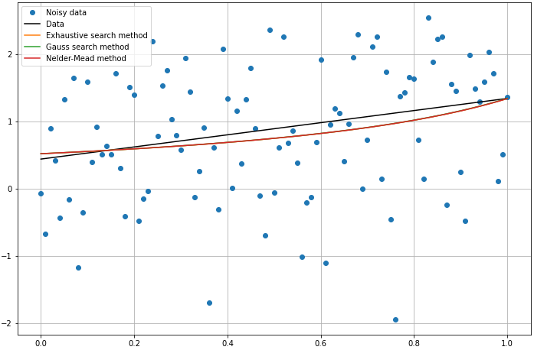

Picture 5 – rational optimization

All methods in each of the approximation functions came to the same value of the minimization function. As expected, the exhaustive method required more iterations and f-calculations than others. Also, for each approximation function, the Gauss method required fewer iterations than the Nelder-Mead method. However, the Nelder-Mead method required fewer function evaluations.

**Conclusion**

As a result, methods of unconstrained nonlinear optimization were implemented to deal with two particular problems. One-dimensional optimization was used to solve a problem of approximating the minimum of a function, we used exhaustion method, dichotomy and golden section. Dichotomy was better in minimum number of iterations and golden search was better in the minimum number of function calculations. For multidimensional (in particular, two-dimensional) optimization, a function approximation problem was considered, for which three types of minimizations were implemented for two approximation functions.

**Appendix**

Source code is available on <https://github.com/sophia-vdovkina/Analysis-and-development-of-algorithms/blob/main/Task%202/task.ipynb>